The Lord’s Prayer

Our Father, who art in heaven, hallowed be thy name. Thy kingdom come, Thy will be done on earth as it is in heaven. Give us this day our daily bread and forgive us our trespasses, as we forgive those who trespass against us. And lead us not into temptation, but deliver us from evil. For thine is the kingdom, and the power, and the glory, forever. Amen.
Prayer of Consecration
Breaking Bread
Prayer after Communion
Eternal God, we give you thanks for this holy mystery in which you have given yourself to us. Grant that we may go into the world in the strength of your Spirit, to give ourselves for others, in the name of Jesus Christ our Lord. Amen.
*Singing Our Faith #731 (vs. 1 & 4)
“Glorious Things of Thee Are Spoken”
*Blessing and Dismissal
*Postlude
Scatter to Serve God & Neighbor

Welcome to all! We gather to praise God for the innumerable blessings given to us and to grow deeper in the Spirit. Joyfully, let us lift our hearts to God.

DIRECTORY OF CHESTNUT HILL UNITED METHODIST CHURCH
Adam J. White | Minister
Sharon Mayhew | Director of Music
Monica Campbell | Administrative Assistant
Judy Martin | Bookkeeper
Judy Robertson  Elizabeth Nichols | Lay Leader  Missionary in Henry County


C hestnut Hill
United Methodist Church

Making disciples of Jesus Christ
for the transformation of the world.
You are welcome at Chestnut Hill UMC.

4660 Fort Avenue ~ Lynchburg, Virginia 24502
Church: 434-239-8423
Minister’s Cell: 434-944-7723, Minister’s Email: awhite@ves.org
Email: chestnuthillumc@comcast.net
On the Web at chestnuthillumc.net
Find us on Facebook: Chestnut Hill United Methodist Church

Chestnut Hill United Methodist Church

10:30 a.m. ~ March 1, 2026 ~ Second Sunday in Lent
Our ministry vision for the Virginia Annual Conference is “to be
disciples of Jesus Christ who are lifelong learners, who influence others to serve.”

Welcome! Join us in worshiping God!
Prelude
Welcome and Ministry Announcements
Welcome in the name of Christ our Lord. Please register your attendance, printing your name, address, phone, and email, on the attendance pad provided on your pew. Thank you for silencing cell phones as we gather to worship God.
Invocation
*Greeting
I lift up my eyes to the hills. From whence does my help come?
My help comes from the Lord, who made heaven and earth.
The Lord will not let your foot be removed,
the Lord who keeps you will not slumber.
Behold, the One who keeps Israel
will neither slumber nor sleep.
The Lord is your keeper;
The Lord is your shade on your right hand.
The sun shall not smite you by day,
nor the moon by night.
The Lord will keep you from all evil, and will keep your life.
The Lord will keep your going out and coming in
from this time forth and for evermore. Amen
*Singing Our Faith #173 “Christ, Whose Glory Fills the Skies”

Opening Prayer

O God, whose glory it is always to have mercy: Be gracious

to all who have gone astray from your ways, and bring them

again with penitent hearts and steadfast faith to embrace

and hold fast the unchangeable truth of your Word, Jesus

Christ your Son; who with you and the Holy Spirit lives and

reigns, one God, for ever and ever. Amen.

Greeting Friends and Neighbors

Prayer of Illumination
Loving God, as we enter this sacred season, we come hungry for renewal and thirsty for your righteousness. By your Spirit, illumine your Word to us now. Help us to hear not just ancient stories, but the living truth of your grace. Shape our hearts to repent sincerely and to live with intention. May the journey of these days deepen our faith, strengthen our hope, and prepare us to celebrate the victory of Easter. Amen.

Scripture Lesson John 3:1-17
The Word of God for the people of God.

Thanks be to God.
Singing Our Faith #163 “Ask Ye What Great Thing I Know”
The Good News “Brand New”

Bringing Forward God’s Tithes and Our Gifts
*Doxology # 95 Praise God from whom all blessings flow; praise him, all Creatures here below; praise him above, ye heavenly host; praise Father, Son, and Holy Ghost. Amen.
*Prayer of Thanksgiving
Sharing of Joys and Concerns

**Calendar **
Tuesday, 3/3 | 1:00 p.m. | Homeschool Play Rehearsal
**Looking Ahead on the Calendar **
Sunday, 3/8 | 10:00 a.m. | Choir
Monday, 3/9 | 7:00 p.m. | Wesleyan Group @ Jessen Home
Wednesday, 3/18 | 10:30 a.m. | Merry Martha’s Circle  Prayer & Self Denial program. Followed by lunch at Charley’s.
Daylight Saving Time
Next Sunday, March 8th, Daylight Saving Time begins. Set your clocks ahead one hour on Saturday evening, March 7th.
Souper Bowl of Caring
We are collecting for Souper Bowl of Caring, to benefit “Meals on Wheels”. For donations, please use a pew envelope. Make checks payable to “Chestnut Hill UMC” and mark it for “Meals on Wheels”.

Birthdays Coming Up: (March) 5-Kitty Burgess.
6-Rev. Adam White

For the Grocery Cart:
March ~ Canned Chunky Soups & Canned Vegetables (Pull tops)

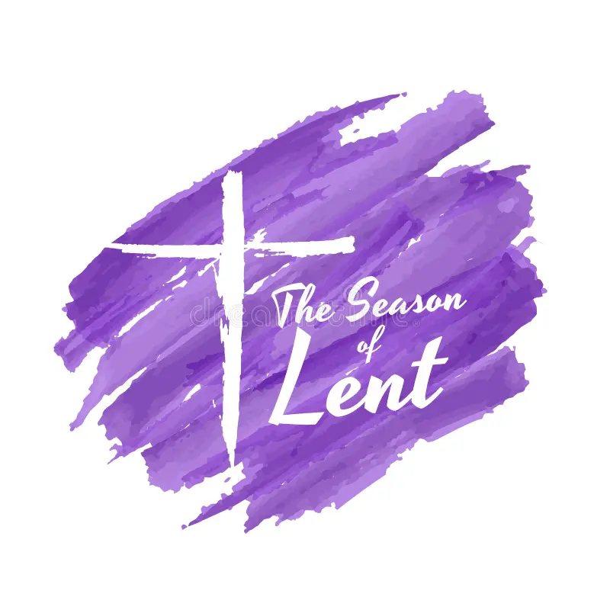

**Calendar **
Tuesday, 3/3 | 1:00 p.m. | Homeschool Play Rehearsal
**Looking Ahead on the Calendar **
Sunday, 3/8 | 10:00 a.m. | Choir
Monday, 3/9 | 7:00 p.m. | Wesleyan Group @ Jessen Home
Wednesday, 3/18 | 10:30 a.m. | Merry Martha’s Circle  Prayer & Self Denial program. Followed by lunch at Charley’s.
Daylight Saving Time
Next Sunday, March 8th, Daylight Saving Time begins. Set your clocks ahead one hour on Saturday evening, March 7th.
Souper Bowl of Caring
We are collecting for Souper Bowl of Caring, to benefit “Meals on Wheels”. For donations, please use a pew envelope. Make checks payable to “Chestnut Hill UMC” and mark it for “Meals on Wheels”.
Birthdays Coming Up: (March) 5-Kitty Burgess.
6-Rev. Adam White

For the Grocery Cart:
March ~ Canned Chunky Soups & Canned Vegetables (Pull tops)

